West Hull Ladies
RRC

March Newsletter
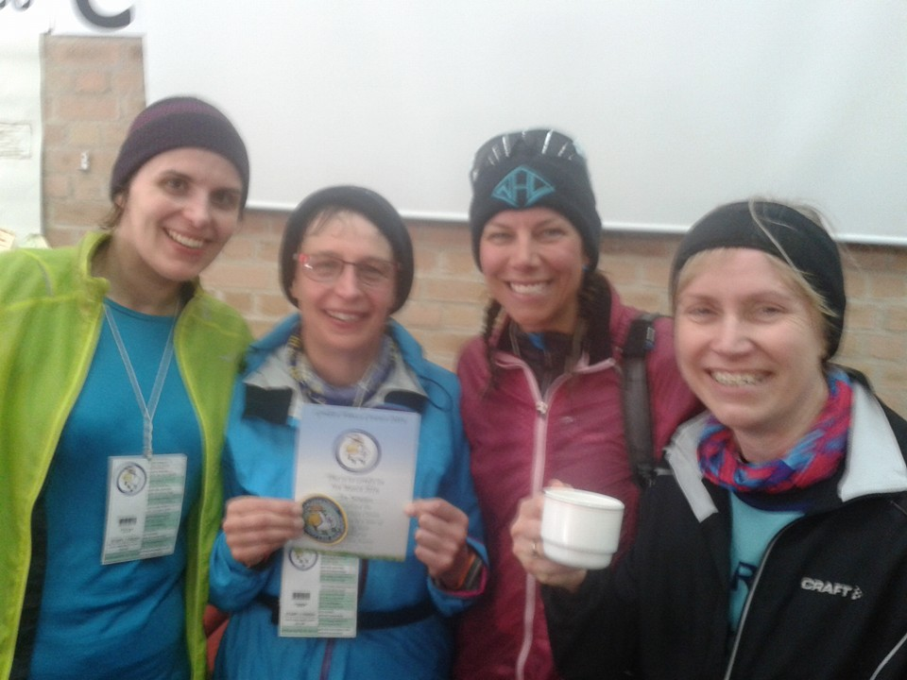
Golden Fleece Girls

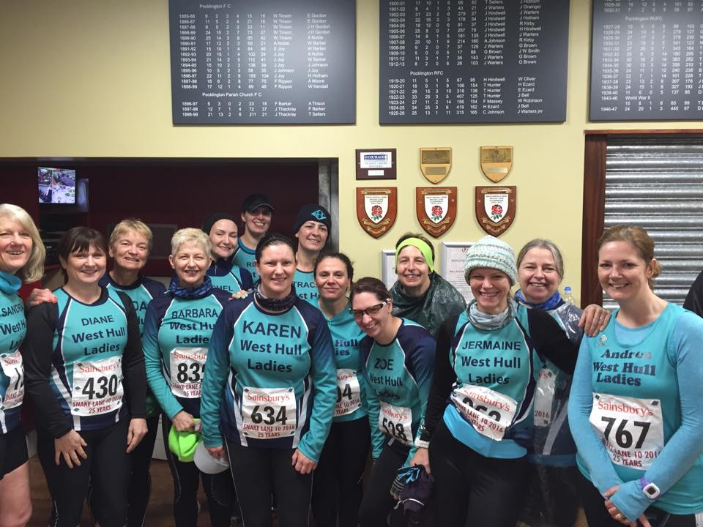

West Hull Ladies : Committee Meeting

Minutes from the AGM 2016
Present - Jill, Linda, Maria, Anna, Amanda, Karen, Sandra, Suzanne, Pam
Apologies - Jan, Liz, Annette, Rachael, Zoe, Andrea.

- Minutes of previous AGM on Monday 2nd March 2015 agreed as correct.
- Chairs Report from Jill. The Club over the last year has gone from strength to strength with membership up and members competing in a variety of events from Marathons, 24-hour events and the Champagne League. We had even won a team prize in the Brigg Poppy Run - a first for the Club. As a Club we received compliments from other clubs within the area and we are recognised as a group who not only trained hard but also helped at other events and supported each other. Hull Marathon was an example of this when we packed the goodie bags, helped to marshal, and manned a water station.
As a Club we received 1 place for the London Marathon and Rachel Whittaker was awarded this. She will be joining Sandra and Linda (Good for Age places) and Sarah Frost. In total we had at the last count some 12 ladies running spring marathons - Rotterdam, Brighton, Manchester and Milton Keynes along with London.
4 ladies had trained, as Leaders in Running Fitness and this had been part funded by the Humberside Area Network, which no longer provided this funding.
The Club had made purchases of an events tent and a new banner both of which had been put to good use at 24-hour events and the Hull Marathon.
The Chair then thanked all the Committee Members for the hard work that they had put in to make sure that we were the fun, thriving Club that we are. This included Maria as the Kit Officer, Andrea and Karen for being the Admin for our Facebook page; Linda, Anna and Andrea for the Weekly news roundup, the Monthly Newsletter, and the parkrun weekly update. Amanda as Lead Coach was thanked together with Linda as Treasurer, Sandra as Secretary, Karen as Members Secretary, Zoe as Race Officer, Annette as the Liaison officer, Liz as the 10k Series Officer and Events Officers Jan, Rachael, Anna and Liz. Special mention was made to Jan for organising the Presentation Evening due to take place Saturday 12th March 2016.The Committee members also thanked Jill for all her hard work as Chair.
It was also mentioned that the communication at the Club was second to none. Many members took advantage of Facebook to arrange non-club day runs and we had training emails provided by Amanda together with an excellent web page. Amanda was thanked for this. All in all we as a Club had a great 2015 - training on the track at the invitation of City of Hull AC and organising the Advent Calendar Run and Cottingham Lights.
Every single member contributed to the Clubs success.
- Report from Treasurer Linda - Linda provided a copy of the Accounts, which showed that the balance as of 31st December 2015 was £3575.23. She stated that we had a healthy balance and made a small profit this year however had we paid rent then we would have made a loss. As most kit was now ordered direct from the supplier by members the small amount we used to make from this was no more. Linda stated that the membership fee would remain at £30 per year and this was now due. She asked that members paid as soon as possible and by bank transfer, cheque or cash. Bank transfer is the preferred way but members can pay on the Presentation evening.
- Report from Members Secretary Karen. Karen said that at the present time we had 74 members although not everyone would renew this year. New members came from the 0-5k beginners programme and also from races/runs were other ladies saw how friendly and supportive our members were to each other. We had 2-second claim members and 3 transferees from different Clubs. Karen also reiterated Linda’s comment that membership fees of £30 should be paid as soon as possible to enable her to get members registered. There was no need for previous members to submit a form unless any of their details had changed.
- Report from Lead Coach Amanda. Amanda thanked all Leaders for leading sessions on the 3 Club nights per week. 4 new Leaders had been trained over the year but 1 would not be renewing her membership but would still help at times with the 0-5k programme. All ladies that helped and are still helping as buddies for the 0-5k were thanked. Without their help the course would not be the success it is. In relation to the 0-5k it had helped this year having a separate email account for the group. Jill and Linda had been trained in all aspects of this, which would help if Amanda was not available. This year we had been given 18 places for the Champagne League all of which had been taken. Last year had once again been successful with many ladies taking prizes.
- Election of Committee Members -
- Chair Jill
- Secretary Sandra
- Member Sec Karen
- Treasurer Linda
- Liaison Officer Annette
- Lead Coach Amanda
- Kit Officer Maria
- Newsletter Anna
- Racing Officer Zoe
- Parkrun Liaison Andrea
- 10k Series Liz
- Radio Linda
- Press other Liz
- Events Jan Maria Anna
Leaders in Running Fitness (LiRF) Debbie, Jan, Jill J, Karen S, Linda, Maria, Sandra, Sara E, Verity, Zoe. Coach in Running Fitness Amanda D

All the above we nominated and seconded by Amanda and Maria except Amanda who was nominated and seconded by Jill and Linda and Maria who was nominated and seconded by Karen and Sandra.

Meet a Member : our West Hull Laddie

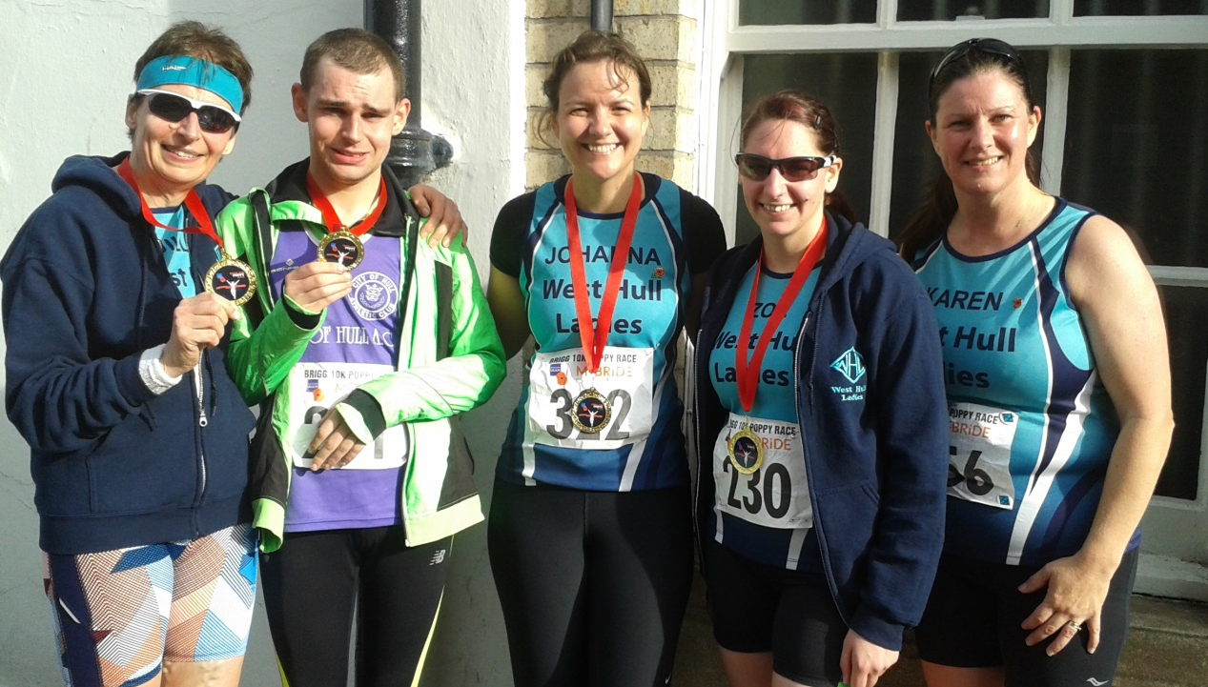
Mike at the Brigg Poppy race with Mum Jill, Johanna, sister Zoe and Karen.

Name: Michael Jameson
Age: 24

Member of WHL since: I am not really a proper member of WHL more of an honorary member. I am actually a member of City of Hull AC, and have been since 2015, but because I have autism and have to run with a guide runner to keep me safe, I sometimes run with my mum Jill or sister Zoe (who are members of West Hull Ladies). My carer at my house used to run with me, but he left so I don’t have anyone to run with anymore, so I sometimes run out with my mum at West Hull Ladies. You will probably see me on a Friday doing speed training, which I really enjoy, as I love running with you all. I then go back to my mum’s house and have spaghetti bolognaise, which is my favourite dinner.

What do you do when you’re not running? I live in supported living and go to a specialist autistic day care facility twice a week. I also go to a care farm on a Friday, because I love animals. One day I let all of the chickens out by accident! I also do lots of drawing, make plasticine models and enjoy riding my mountain bike. Sometimes my mum has difficulty keeping up with me on my bike because I am quite fast and seem to have boundless energy. My running friends Linda and Amanda have given me some lovely books about dogs and other animals which is great because I love looking at picture books.

How long have you been running? I started running in 2014 with my mum and my sister. The first event I did was a 3k run organised by Beverley Lions, on New Year’s day. I went off very fast and then got stitch, so had to walk, but I did manage to finish it, and was pleased with my medal. I think it also was one of the first races that my Auntie Liz did too.

Why did you start running? I have always done running, in fact I used to run away from my mum a lot when I was little. One day I vaulted into a cow field and ran amongst all of the cows. It was hilarious because my mum nearly fell over the gate into a cow pat trying to run after me. Before she started running, my mum was over 13 stone and never could catch me when I ran away. Even now she still can’t catch me, but I don’t run away as often as I used to, which she is glad about!

Favourite distance: I run up to 10k because I don’t understand how to fuel for a longer race. I don’t think that they do spaghetti bolognaise or pepperoni pizza flavoured gels, and I prefer Mr Kiplings iced fancies (particularly the pink ones) rather than flapjack. I think the iced fancies might get a bit squashed if I put them in a running belt, so I will be sticking to 10k!

Favourite bit of running kit: My blue trainers. This is because this is my favourite colour.

Any injuries: No, but if I get blisters I will stop and expect my mum to pick me up in the car!

Running goals? My mum has entered me into this year’s Champagne league. Hopefully my fast running friend Wayne will be able to run with me, otherwise I think mum might have to tie me to her so that I don’t get lost! I am also running Lincoln 10k. I am looking forward to the medal because I like to win medals. I got a really nice medal shaped like an Easter bunny when I did the Bridlington 5 mile race last year, and I loved the one from York 10k which had a church on it!

Proudest moment running related or otherwise: In terms of running, I was fourth in the City of Hull AC winter league this year. Fortunately for my mum, I had quite a few people running with me to keep me safe, as I am faster than mum. However, in the January race, mum had to run with me, except that she couldn’t keep up. I think I might have beaten her by over a minute. She was a bit red faced when she came over the line, I can’t think why? My other proudest moments were when I won the student improver prize when I graduated from Linkage college in 2014, and when I met Alice in Wonderland at Disneyland Paris, where I managed to give her a kiss! I think my mum was a bit worried about Alice, but I don’t think Alice minded!

Best piece of advice you’ve received: My mum is always telling me to slow down, when I am running, but I don’t really know why that is, and to be honest, I often slow down for a bit and then speed up again, particularly when people cheer and clap! People also have to remind me to put my running clothes on the right way around as I don’t always notice these things. One day I had my running tights on inside out and back to front. Perhaps this is family trait however as my mum went running with her skins on inside out one day!

Running alone or with friends? I always have to run with friends because I don’t have any road sense and I don’t always know where I am going. I sometimes get quite distracted. I ran into someone’s garden one day when I saw a fox. This is why I love running with my friends at West Hull Ladies, as they keep me focussed on what I should be doing. I particularly love speed training with Debbie and Sara and enjoy skidding to a halt when we are told to stop. I enjoy doing dynamic stretches too!

What keeps you motivated? Running with my mum and her friends from West Hull Ladies, as I enjoy being part of a group, although I find it difficult to chat like mum and her friends do. Sometimes I say things that others might find a bit odd, as I tend to repeat phrases from Disney cartoons that might seem appropriate to me in the situation, but might be confusing or even impolite to others. This is because I don’t understand social situations very well, and I can’t read people’s reactions. Running does make me happier however and I find that I can cope with challenging things more easily when I have been running.
Mike and his Easter Bunny Medal and also his plasticine picture

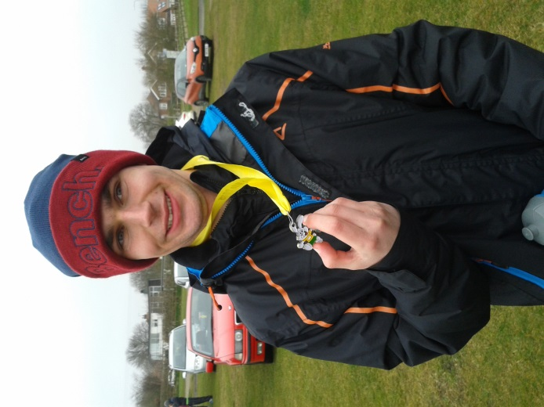
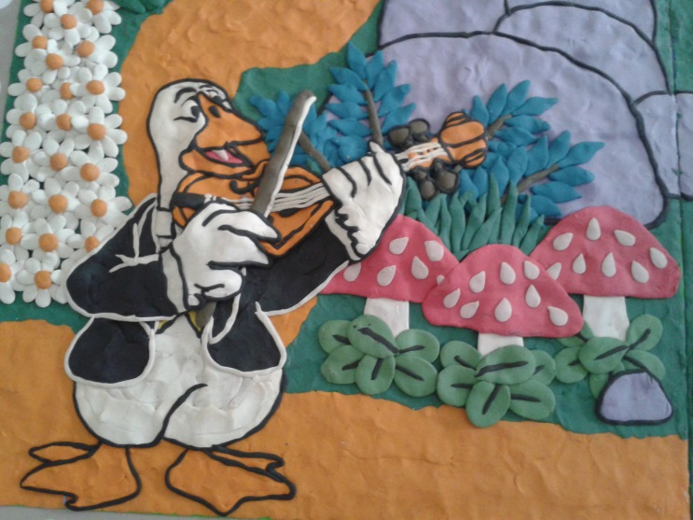

Snake Lane (10 miles) : Sandra

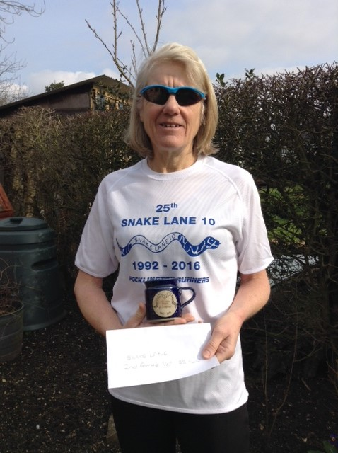

I have run Snake Lane on 3 previous occasions and have usually enjoyed it despite as I recall it always being very windy and cold and whilst it is billed as flat I find it undulating and definitely not flat!
On the Saturday night I checked my previous times on this course and saw that in 2013 I managed 1hr 21 - 2014 1hr 28 and last year 1hr.25. So it didn’t look like it was a course I favoured.
The start time of 11am is pretty civilised but it does mean hanging about a bit.
I drove to Pocklington, parked up and then made my way to the HQ at the Rugby Club.
It was lovely to meet up with all the other WHL’s who were also running and also our own photographer Sharron.

There is a 5-minute walk to the start and as I was making my I got chatting to a lovely guy from near Stockton. He was a great help to me in the later stages of the race.
At the start line I met up with Jill, Zoe and Jill and at 11am the horn went and we were off.
For the first time I never tied my hair up - I had intended to wear my snood over my head but it got too warm and so I had to pull it down. I then spent the rest of the race eating my hair, trying to use the snood as a hairband and failing badly.
After about half a mile Jermaine came zooming past me - strange thinking back that we ignored each other.

I felt quite good and when I was looking at my Garmin I was surprised to see that I was less than 8 - minute miling.
Things were looking good and I was hoping that with all the hard threshold/interval training I had been doing in preparation for the London Marathon I would be able to hold out.
I reached the 5-mile mark and had a gel - actually stopped to do this as I was struggling and thought in the long run it would be quicker to get it down and then start again.
At 10k I looked at my watch and saw it was 49mins - I think at that point I was irrationally thinking that I wasn’t doing too well and I thought ‘maybe your marathon training isn’t going as well as you thought’. I have no idea why I thought that but I was pleased I did as it made me push on. I could see Jermaine in front of me and knowing how well Jill is running I was expecting her to come onto my shoulder at any point.

At about 8.5 miles there is a climb up into Pocklington before it peters out and it then goes downhill.
As I was going up the hill although I felt okay I could feel my legs slowing. Just when I needed it I heard someone say ‘Come on West Hull Lady’. I didn’t know at that time but it was the guy I had been talking to earlier. He kept me going telling me how far we had to go and before I knew it I was sprinting for the finish. When I looked at my Garmin I saw that I had managed 1hr 19mins 53 seconds. Wow a pb by 2minutes and under the magical 80mins. I was over the moon and then I saw Jermaine who had finished in 1.18.33. Terrific - so the marathon training is going well.
I later learnt through Karen - thank you Karen that I had got 2nd place in my age group. The day just got better!
Sandra

Snake Lane (10 miles) : Jermaine

Hi, well I had booked the Snake Lane way before I booked a place in the Manchester Marathon, just because I remembered enjoying the route and the distance last time in 2014. However, with marathon training going so well and my previous attempt at the Snake Lane 10 being 2/3 weeks after getting my cast off a broken ankle, they were destined to be very different races.
On the Saturday I kept looking at the weather forecast - not just because I was worried about ice, rain, snow but also to work out what to wear. The weather looked like it would be perfect (except for strong gusts of wind) Well that seems to be a theme on Snake Lane - I can remember both me and Jill getting pushed backwards by strong winds in 2014. Anyway decision on what to wear and what to take to put on after made, the next decision was who was driving as lots of WHL were taking part and it seemed silly for us all to drive.

Karen very kindly offered to drive and collect me. I woke up on the day, and felt nervous, I almost didn't want to go I felt that bad, I had had a sore hip earlier in the week and hadn't had the opportunity to see the physio, luckily the pain had worn off so I was feeling fit, just nervous and sick. Nevertheless, I got dressed and Karen picked me up as arranged at 8:45 we then collected Barbara. We were meeting other ladies at Rachel's on Boothferry, not that any of us could remember exactly where on Boothferry but Rachel came out to meet us and we set off in two cars. I have to say a massive thank you to Karen & Babs here because we all had a good old natter, putting the world to rights that during the journey I forgot my nerves - so I can advise else who suffers from pre-race nerves to do a car share.

We got to Pocklington Rugby club and then the nerves started to take over my body again, I had countless trips to the loo, felt sick, shaky and generally crap - I don't know why I get this way, I know it is irrational and it isn't like I am going to win but unfortunately that is the way my body works (maybe the reason I don't enter too many races either) Slowly but surely all the wonderful WHL started to gather - I was looking for Sandra as she had a flip belt that she was loaning me, so we jogged down to her car (parked what felt like 10 miles away haha) but the jog did us both good, when we got back to the club all were gathered and we had a photo shoot. It was lovely to see Debbie and Sharron who were out to support us.

The organisers ask you to wait in the rugby club and not at the start and then they usher you approx half a mile to the start. I walked with Ros and again the nerves were getting the better of me and I thought I was going to be sick, but Ros kept me calm and gave me a big hug. We crowded near the start and it was manic, soooo many people loads of different colours from all the various clubs. People of all ages and sizes and one person who near us who had been there 25 years ago when the Snake Lane 10 took place for the 1st time.

I thought to myself if I had taken part all those years ago I would be doing a Jo Pavey as it would have been 6 weeks after giving birth to Lucy !

The gun went off and me and Ros stayed together, however I got into a set pace and said goodbye to Ros, I saw Sandra to my left up ahead and just kept at my pace, which felt really steady - it is surprising what can feel a steady pace on a race feels like super speedy when you're out on your own trying to do threshold. At some point probably about a mile in I think, I passed Sandra, from then on it was just keeping a pace and having people as markers. The route was more undulating than I remembered but I quite like that anyway. It took me quite a while to feel my legs loosen off properly but by the 5 mile marker I was running with ease and it just felt great. (My nerves left me in the 1st 100m) As we got onto the more open windy roads the wind had picked up and so I remembered the advice of Sandra, look for a tall man and stick behind them, they can shelter you from the wind. I did this but often their gait was so different I thought I was going to trip them up. So I moved from one tall man to another, it must have looked quite funny. I even had time to chat to a couple of them and thanked them for being wind-breakers. In the last 3 miles I managed to overtake quite a few women & men that I had noticed whizz past me at the start and that felt good! All that hill training paying off as many of them slowed on the hills. I had a bit of a battle with one guy on the hills, I overtook on the up, they overtook on the down and this happened a few times but luckily for me the last stretch of race going into Pocklington is an incline and I managed to get past with enough energy to gain pace to put distance behind us. The last mile - YES! approx half a mile from the finish I saw the lovely Sharron and she was cheering it really helps when that happens! However lots of tall men were passing me - 200 m to go and I managed to get a sprint on, turning the corner to the finish line and I heard Rich call out my name and it made me go even faster. I was done, pressed my Garmin and saw I had finished in 1:18: 41 - I couldn't believe my eyes!!! My watch doesn't show time when I run, just pace, so I was overwhelmed when I realised I had gone sub 1:20. I had been hoping for anything between 1:20-1:25. Shortly after getting my T-Shirt, cup and my breath back I saw a flash of turquoise and it was the amazing Sandra, we gave each other a massive hug - I am not ashamed to say I cried, in fact I cried several times that day. It was just so overwhelming. One by one the WHL came in, but I will let them tell their own tales of the race. Sandra said 'come on Jermaine, we need to jog, keep your legs going, don't let them stiffen up' - so we jogged to where Sharron was and cheered the ladies (and men) in. I had been given the duty of getting hoodies and bags from the car, for the others, for when they finished so off I trotted with Sandra to collect the stuff, which meant I missed some of the ladies coming in.

After all of us had crossed the finish line some of us went back to the Rugby club to get a hot drink and hear who had won, Sandra had won a prize!! Another to add to her well-deserved many! With that it was back home, Babs had been collected by her husband so it was just me and Karen in the car, chatting away until she dropped me off.

After the excitement of the morning it was back to the reality of cleaning the house, doing the washing and marking books ready for school the next day.
I was eagerly waiting for the official results, which Sandra then found and posted. My official time was 1:18:38 (3 seconds faster than my Garmin time) I came 7/63 in my age category and 58th woman to cross the line. Oh and an added bonus, when I uploaded my data to Garmin Connect, I had only gone and smashed my 10k time too, my new PB on my 10k is 48:13 which is a PB of 1min 34 seconds. It is really not easy to live with pre-race nerves but I will try to embrace them as they clearly work in my favour.
Well done to all the WHL you are all incredible!! Jermaine

Dalton Dash : Kate B

(Sunday 28th February)

When Diane Pickering offered up her place on the Dalton Dash I jumped at it for 3 reasons: firstly, I had not done a 10K in a little while, secondly, I think the scenery around there is lovely and thirdly, I am keen on the Pipe and Glass – the pub who were doing the after-run snacks, (including a huge piece of flapjack). When I found out Jill Jameson had also signed up I was really pleased as I knew running with a WHL always doubles the fun.
The pre-race set up was pretty good – quality toilets and bit of up-beat music were making us feel relaxed and, apart from the cold, weather conditions were set fair. We saw a spectator wearing a formal suit ( so looking a little out of place), and presumed him to be a representative of the Hotham family whose estate we were running around – good of him to wave us off I thought. The course is entirely undulating – there’s very little flat. Jill and I both had a great race. I was amazed to be able to keep Jill in sight. At 8 Km I managed to catch Jill up and overtake for about 5 seconds. Jill quickly pulled away though and showed a really strong pace in the last 2 Km. I had to do an uphill sprint finish at the end as I could hear these 2 people racing up behind me (probably racing between them), and decided to get involved and not let them pass me. Probably a foolish thing to do on retrospect but on studying the results today I see managed to prevent them from overtaking me, (yes!). At the end Jill suggested that we might want to stick around to see who had won in our age category. I am so glad we did as Jill won the 50 plus category. I don’t know who was the happiest – myself or Jill. Overall, a really good race. We should look at it again next year girls. Only 200 competitors so it probably fills up quickly.

A Weighty Question: Jill’s story

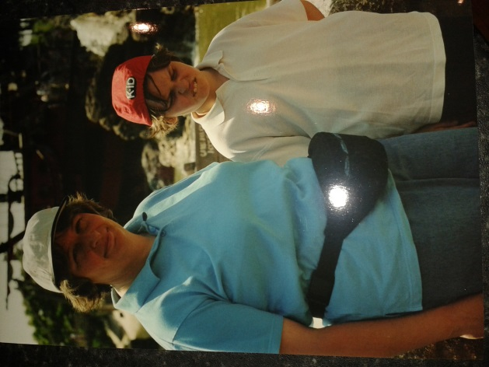

The first thing that I want to say is that I think the question of eating, running and weight is a difficult one because women in particular are affected adversely by media images of skinny models and desirable body shapes. I firmly believe that anyone can run regardless of their body shape and we should celebrate body shapes of all types. When we look at international athletes we tend to think they are all skinny, but this is not the case, as there are some amazingly fit ladies who are different sizes and shapes, just look at Serena Williams for instance! The question here is about taking possession of your body and your mindset in relation to this, and being happy in your own body and what it can do, whatever shape or size it is.

The three pictures above are of me at different times in my life. The first one shows me at in my late 30’s, very unfit and somewhat overweight, and certainly not a happy bunny. The second picture is me in 2014, lots fitter and running at the Thunder Run where I completed 40k, but a bit heavier than I am now.
The third picture is me at Snake lane in 2016, although I have to say that the new vests and skins running tights are more flattering than the old kit and shorts lol!

It is important to note that I am not advocating my story as being the right way to go, or my body size as something that everyone should aspire to. We are all runners and are equally awesome, and we should never undermine what we achieve by comparing ourselves critically against others, as we are all different and have different aims in life.

At the age of 40, I guess I had a midlife crisis, and was really not happy in my body at all (I did not have the best dress sense either, as you can see by the photo above lol!). After having had three children, and eating lots of takeaways and junk food, as well as routinely eating food that my kids left on their plates, my weight had got to around thirteen and a half stone, and being only around 5’ 4’’, that is quite heavy for my frame. I found myself puffing and blowing when I was walking upstairs, and the only exercise I did was unsuccessfully running after my autistic son Mike when he ran off, which he did at regular intervals.
I decided at that point that if went on like I was, I would be having serious health issues at the age of 50. This was my motivation. At that point I did not go on a diet as such, but actually changed the way I bought food and what I ate.
I did not buy any biscuits and crisps, much to the upset of the rest of the family, because I could not trust myself not to eat them. I think the important thing is about knowing yourself. I still have issues with things like biscuits, cakes and chocolate, so I don’t regularly buy them, because I know I will eat them. I took fruit and raw carrots to work, and tried to take a packed lunch to stop me going down to the refectory, where there would be so many lovely cakes to tempt me (Newly baked scones are my Achilles heel!).
I also cut down my portion size, used smaller plates, tried to eat more healthily, lots of salad and raw foods, avoid chips and particularly bread (this is the devil food for me!).
I ate more fish and chicken, and avoided pies and processed food, to a point. Having said this, I still ate sweet things when it was a special occasion, but not as a regular thing.
I also started to use my exercise bike, which has previously been used as a clothes dryer, and I got a second hand stepper and some weights from the charity shop. I started this change of eating and exercise over the summer holiday, whilst I was away from work, which I think helped enormously, because by the time I went back, I had lost around a stone in weight, which made quite a difference in that I was seeing value in the changes I made. This gave me further encouragement that I actually could lose some weight, because sometimes it seems impossible, and I had tried numerous times before to lose weight with no success.

For me the trick was to actually weigh myself every day at the same time, probably because I respond well to being in control (yes I am a control freak sometimes!). Having lost some weight gave me further resolve to carry on, but I got stuck at about 11 and a half stone about 10 months after I had started my new eating regime. The thing that helped me lose more weight at this time was to discover running, although it was not love at first run, by any means. My daughters Kim and Zoe had been doing a bit of cross country running, so given my ‘new’ body and improved fitness, I went along.

Well after about a couple of minutes running I actually thought I was going to die, so I turned back and did a bit of run/walking. The next day, I really did think I was going to die as all of my muscles were aching so badly, so I decided that running simply wasn’t for me. However, a few days later, I relented and went out on my own, and started to enjoy it. With my eating regime and my running (only 2 miles every other day), I then managed to lose another stone, so was at around ten and a half stone, give or take a few pounds either way. To be honest, I was really happy at this weight, and when I joined West Hull Ladies, I ran some good times. I was proud of my fit body and even though I was the wrong side of 50, I was really happy that I could do all of this running and training and recover really quickly! I managed around 52 minutes for 10k, did a half marathon at just over 2 hours, and completed the Yorkshire Marathon in 4:49.

There were three things that happened that made me decide that I wanted to shed a few more pounds.
- Firstly I kept injuring myself, so I thought that if I lost a bit more weight, this might put less pressure on my joints and muscles, because I was worried about not being able to run as I get really miserable if I’m injured.
- Secondly, I am a competitive being, and I thought that if I did shed a few more pounds that I might be able to go a bit faster.
- And thirdly I had put a bit of weight back on, mainly to do with the breadmaker I bought myself. Seeing 11 stone on the scales was a bit of a wake-up call!
At the same time we had all watched a programme, around at Amanda Dean’s house about how a low carb, low sugar, higher fat and higher protein diet was actually a more healthy one, than a low fat and high carb diet, (yes folks fat is your friend, and yes there is research to support this!). So armed with this idea, I set about putting the breadmaker away and embarking on my version of this way of eating.

For breakfast, I do still eat carbs, either porridge and blueberries, or a very small portion of granola supplemented with nuts and full fat greek yoghurt, it really does fill you up. For other meals I always try and eat ‘clean’, which means make it from scratch, and avoid processed foods. I use olive oils, and butter, I never eat low fat stuff, because it’s full of sugar. I mostly avoid bread and eat lots of raw things. I rarely eat chips…sweet potato wedges are just heaven and much better than chips! I do eat some potatoes, but again, in moderation, and mostly new ones. I don’t totally avoid carbs, but I just don’t eat too many. This has helped me lose around a stone and a half, so I now am at nine stone four pounds. This has improved my running times (which makes me very happy, but I am a crazy woman!), and thus far has resulted in less injuries (but I am touching wood here!).
I rarely feel hungry on this eating regime, although I still can crave the sugar in cakes and pastries; particularly if I eat it…it just makes me want more, so I avoid buying things like this so I am not tempted. But this is about me knowing my own mindset!

So what is the moral of this story: Firstly celebrate where you are now as a runner, whatever shape and size you are: you are amazing…its official; Secondly eat good ‘clean’ food as you are putting your body under stress by running so you need to look after it; Thirdly if you do want to lose weight, think about your own mindset, particularly around your reasons why you want to lose weight, as it helps you to keep on track and also if you organise your strategy, it helps you to come up with ways to avoid products full of sugar, and plan good meals; Fourth, think that you will need to come up with a regime that works for you and your lifestyle. What has worked for me or other runners may not work for you, so pick and choose what you think you can get along with. I find avoiding bread is the easiest way for me to avoid weight gain, but everyone is different; Fifth, don’t make too many changes to your lifestyle at once; don’t criticise yourself if you do occasionally eat cakes and other naughty things, we all do…and why not!; and don’t be disappointed if it takes a while to lose weight, as the slower it comes off, the less likely it is to go back on again, and the most important thing is to be healthy and keep running!

Losing Weight –Sarah JW

I’ve tried them all:

Slimming World - 4lb loss the first week, then nothing lost except money

Weight Watchers - usually stuck at it for 3 weeks before falling off the wagon, but did loose 2 stone on one occasion, then as soon as I stopped counting points, put it all back on again

5:2 - The 2 days fasting were fine, but I made up for it big time on the 5 non fasting days
‘Just cut back a bit – you know how to do it’ – mmmm what’s a bit?

‘Eat less crap, drink more water’ How much less? What’s crap?

My Fitness Pal – usually stuck at it for about 3 weeks before the inevitable binge!
Despite what people say, and despite what I have told myself, running just isn’t enough to make you loose weight. After all a pack of sandwiches from Tesco, which you might think of as a light lunch, can be as much as 700 calories, and it takes me an hour of running to burn that off! So this new year, as every other, my resolution was to loose 2 stone.

Only this year something was different. An inspirational conversation with Jill Jameson just before Christmas got me thinking about carbs and how I’ve got the low fat, high carb thing a bit wrong over the years.

Then I read an article in Runner’s World about someone who’d lost a humungous amount of weight through running and using weightlossresources.co.uk. A bit more reading, a couple of conversations and a bit of giving myself a good talking to, and off I went to sign up for weightlossresources.co.uk. It’s a good website and cheaper than some of the others. It includes a food diary, a forum, a help team you can phone or email and they get back to you very quickly, support to develop new habits, lots of interesting articles about weight loss and a wide range of plans to follow if you want more guidance.
I’m 2 months in and have now lost almost a stone. It’s not been easy. I love eating nice food in large quantities! The answer has just been to eat less (I know that sounds obvious but some diet plans overlook this detail!), reduce the carbs, track everything I eat or drink, drink more water and just believe I can do it. So far it’s not had a huge impact on my running times, but it’s a great motivator to run more – just think of all those extra calories!

Writing this down makes me nervous that I’ll lose the plot and go back to my old ways, and I’m also aware that maintaining my weight loss will be difficult, if and when I get to my target, but I’m half way there, and I’m beginning to think I can do it!

Sarah JW

Weight Problems!–Linda

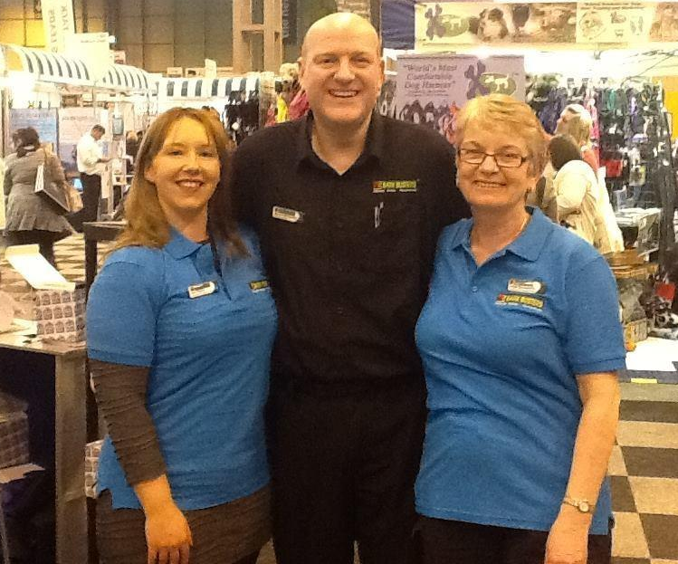

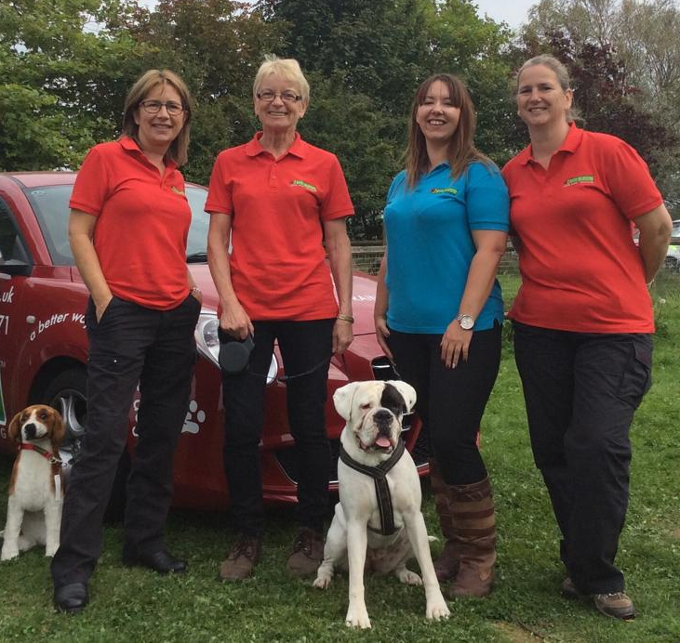

Three years ago this week I was getting ready to go to Crufts with work, we had to wear our uniform which I hadn’t had on since the summer. On the morning of Crufts I got dressed and these darned black trousers would hardly pull up over my big bum but I managed (thankfully as they were the only black trousers I had)! These trousers were a size 14 and now I couldn’t do them up, out came my trusty sewing box and thankfully I found lurking in the corner a huge nappy pin, this pin held them together for the whole day and boy was I uncomfortable. My uniform top which was a polo shirt was also way too tight, I felt as though I was going to bust out of it. I looked and felt a mess. On seeing the official photos a few days later made me realise just how much weight I’d put on over the winter months and I was distraught. There was no way I was going to buy a new pair of work trousers for the spring/summer in size 16 so I had to do something and fast.

I love food so how was I going to do this? I bought a smaller plate and started there so although I was eating the same the amount was less. I stopped buying rubbish to munch on while I was driving so had to keep my eyes averted from all the goodies on display whenever I filled up with petrol or called at the supermarket. This was tough but I kept that picture of fat me in my mind.

I was beginning to feel a bit thinner by the time my birthday arrived the next month, well at least the clothes didn’t feel quite so tight anyway! So I decided to try running because I’d always promised myself I would run a marathon in my 60th year, this was my 59th birthday. My husband (Stewart) laughed like mad when I trotted off out the back door with an old pair of trackie bottoms on and a pair of old trainers, but I was determined. I lasted a mile and had to turn round and walk home but I did it again a couple of days later until I could finally run the mile and turn round and run the mile home. I stuck to my eating plan and soon I was able to enter the Jane Tomlinson’s Hull 10k which turned out to be 9k because a bridge would not open. Everyone was moaning about that but I was glad as the distance was shorter and I still wasn’t able to run continually for that distance anyway. This was the first time I noticed WHL vests, I was intrigued and looked them up on the internet when I got home.

I continued with my ‘training’ and ran the Humber Bridge 10k, well ran/walked/puffed and panted across but I did it. Again those vests, I wanted one! Asked the ladies if I could join them and the rest is history.

The running helped make me lose more pounds, the training helped me get better times and be able to run further without stopping. The encouragement was phenomenal and before long I was buying new clothes sizes smaller than the 16 I thought I was going to have to buy.

In those days I did not weigh myself, I wouldn’t dare, I just went by clothes size. My size today is 8 and I even possess a size 6 dress. I eat better and try not to eat too many sweet things although I still enjoy cake!

Oh and I did run that marathon in my 60th year and it’s all thanks to WHL and their encouragement and I feel great.

My Weight Loss –Sharron

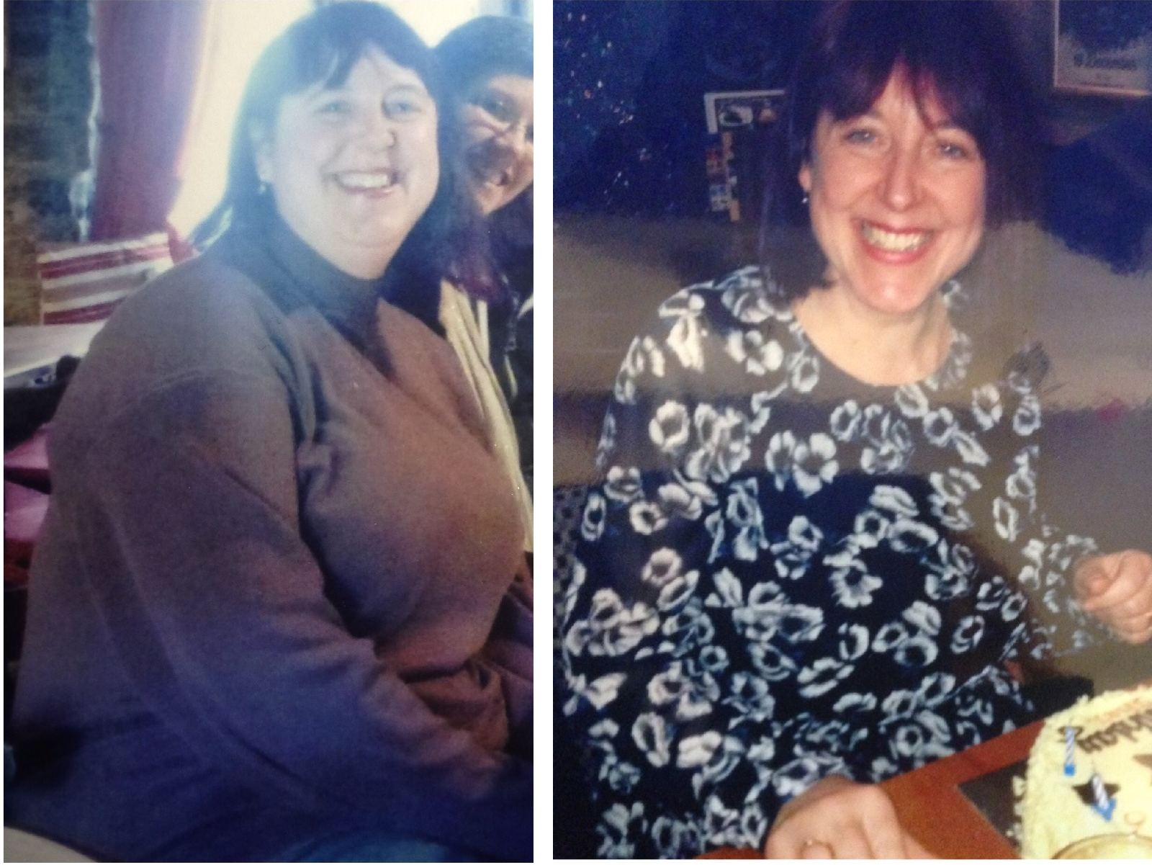

To be honest I didn’t start any type of ‘named’ diet or try the latest fad. As daft as it sounds, I actually tried smaller portions, I realised I didn’t need to have the same amount of food on my plate my husband did. I started to realise that a smaller portion DID fill me up, I just hadn’t realised that fact over the years. I started drinking more water, I thought I was drinking enough but I wasn’t. I drink the recommended allowance now. I initially hated drinking water – used to moan that there was no taste, but, as the weight dropped due to the smaller quantities of food and I began to feel healthier, everything seemed to kick in and work together. I find drinking water refreshing now, I don’t buy bottled water just use the good stuff from the tap.
I’ve kind of gotten into a routine. I LOVE fruit. During the morning I work my way through around 5, 6, maybe……(PROBABLY) 7 pieces of fruit! Early afternoon if I’m peckish I’ll just have a snack, crackers or sometimes a breakfast bar or similar……AT THIS POINT IN THE DAY I MAKE SURE IF I’M FEELING PECKISH TO EAT SOMETHING as I’ve learnt NOT to think “Oooo, I SHAN’T EAT NOW as I can have that bit extra on my plate at tea” because now I KNOW I will pick at things whilst cooking tea.
And then the smaller portions come into play. One important thing to me was knowing when to stop eating. Just because something was so tasty it didn’t mean that I had to get EVERY LAST bit of it down me. I find now that I appreciate the taste more if I stop when I’m full.
It’s as simple as that, to me it was all very much a learning curve.
Then of course, the running helps. As I mentioned before at some point everything kicked in and started to work together………the exercise, the eating less.
That’s it! No great ‘named’ diet like I said, just realisation of something that is so blooming obvious to me now that I didn’t see it all those years back.
xxxxx

Fundraising News

Linda is running the London Marathon and is raising funds for the charity
Boxer Friends Spain
www.gogetfunding.com/boxer-friends-spain.
"This is a new charity and I do lots of free work for them which even includes home checking so the charity knows their dogs are going to a good home. I help with foster dogs too and attend their fun days which always manages to raise some well needed funds. These Boxers are usually in a very poor state when they get rescued so quite often need lots of medical care as well as TLC."

2016 RACE DIARY

Free 5K time trial every Saturday 9am:
Hull Parkrun Peter Pan Parkrun Humber Bridge parkrun

Double check dates, times and entry fees with the official website or the entry form. Zx Website contains all the links to the races: http://westhullladies.org.uk/races.htm

 | Date/Time | Event | Fee | Entry forms | Online entry
Mar  2016 | 13th/10:30 | Newton's Fraction Half Marathon | £18 UKA/£20 | Online entries only | Online entry
 | 20th/10:00 | Gainsborough 10K | £14 UKA/£16 | Online entries only | Online entry (+£0.75)
 | 20th/10:00 | East Hull 20 Miles | £20 UKA/£22 | Entry Form | Online entry (£1.80)
 | 25th/10:00 | Bridlington Easter 5 Mile Dash | £13 UKA/£15 | Entry Form | Online entry
Apr  2016 | 3rd/10:00 | Reading Half Marathon | £35 UKA/£41 | Online entries only | Online entry
 | 10th/TBC | Jane Tomlinson Yorkshire Half Marathon, Sheffield | £30.10 UKA/£32.10 | Online entries only | Online entry
 | 10th/TBC | Greater Manchester Marathon | £58 UKA/£60 | Online entries only | Online entry
 | 10th/11:00 | Hornsea Third Marathon | £12 UKA/£14 | Entry Form | Online entry
 | ch17th/11:00 | Jane Tomlinson City of Lincoln 10K | £24.75 UKA/£26.89 | Online entries only | Online entry
 | 17th/11:00 | Burton Pidsea 10K | £11 UKA/£13 | Online entries only | Online entry
 | 24th/TBC | Virgin Money London Marathon | Race Full | Race Full | Race Full
May  2016 | 8th/09:30 | Jane Tomlinson Leeds Half Marathon | £30.10 UKA/£32.10 | Online entries only | Online entry
 | 8th/11:15 | Beverley 10K | £13 UKA/£15 | Online entries only | Online entry
 | 15th/09:00 | North Lincolnshire Half Marathon | £26 UKA/£28 | Online entries only | Online entry
 | 15th/TBC | Jane Tomlinson Nottingham 10K | £25.82 UKA/£27.96 | Online entries only | Online entry

NOTE: Club Vests must be worn at any races you enter
under the West Hull Ladies running club name.

Kit Order Form

NEW STYLE VESTS are purchased direct from www.pbteamwear.co.uk
On website: click on Clubs, Athletics Club, West Hull Ladies RC
Pick your size, name you wish to have on the front and follow payment instructions

For all other purchases use this form.

FORENAME ___________________________________
SURNAME ___________________________________

ORDER - tick what you require and circle your size Price
- OLD STYLE VEST SIZE 10 12 £10.00 (useful for training)
- LONG SLEEVED SIZE 10 12 14 16 £18.50 £10.00 (useful for training)
- HOODIE SIZE XS S M L £20
- HOODIE with ZIP SIZE XS S M L £20
Note on size: M is approximately size 14

- BEANIE HAT £6.50
- PINLESS WHL NUMBER FASTENERS (set of 4) £3.00

DATE Ordered _______________
AMOUNT PAID _______________

Please transfer payments online with your name and marked as ‘Kit to:
Account: 63762742 Sort Code: 20 43 49

Or cheque payable to ‘West Hull Ladies RRC’, and write your name and ‘Kit’ on the back and give to Club Treasurer Linda Dodsworth, 110 The Stray, South Cave, E Yorkshire. HU15 2AL

Sign on receipt of goods _________________________________
DATE _______________

Please complete this form and email to diazmaria@btinternet.com
Thanks.
Maria Kit Officer

